2.7.1 - Student Satisfaction Survey (SSS)
2020-2021
Feedback plays a vital role in order to take essential decisions in any institute. In this way feedback is beneficial and important information. Appropriate feedback has effective advantages for the students, the professors, the principal and the whole institute. It is one of the suitable means to uplift the performance. Moreover, it gives a proper path for improvement. This survey includes the design of questions recommended by NAAC. It has included teaching-learning and evaluation aspects. Moreover, the survey consists of infrastructure and welfare aspects of the institution. There are many questions and the learners have to fill all the answers on the feedback form. Dharmendrasinhji Arts College, Rajkot SSS was conducted online by providing the google form with questions.
The following points are observed through SSS:
Sr. No. | Parameters | Responses
1 | Teaching -Learning Process | More than 50% of the students have  responded positively
2 | Internal- Evaluation | Almost all learners believed the  evaluation was impartial
3 | Preparation of Academician | Preparation of the teacher for class was very good.
4 | Basic and Physical Facilities | The students were satisfied with physical  facilities provided by the college.
5 | Extracurricular activities | Our college regularly takes active interest in promoting extracurricular activities. All the students replied in positive way

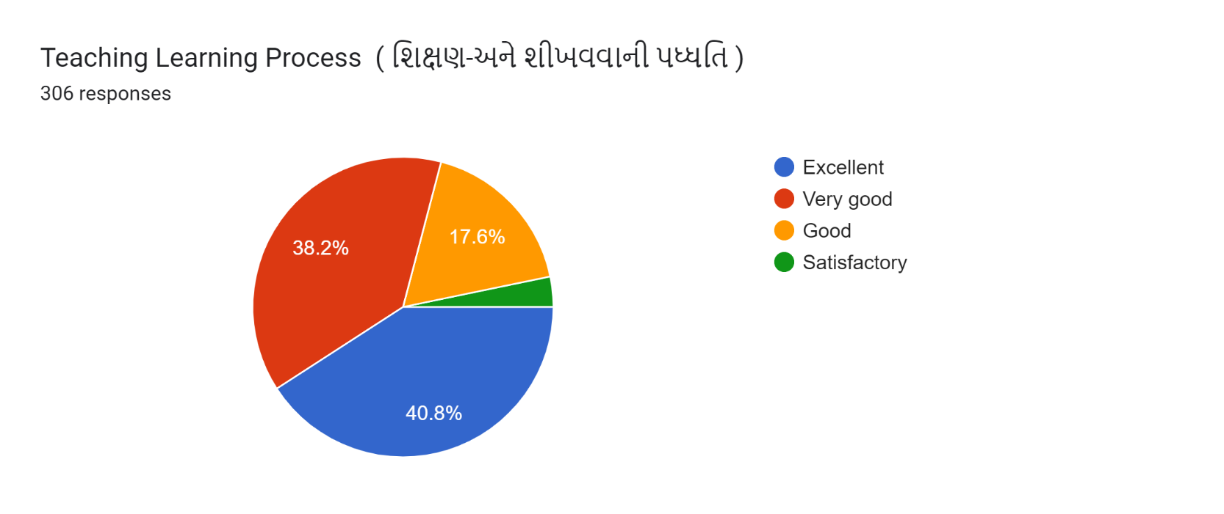

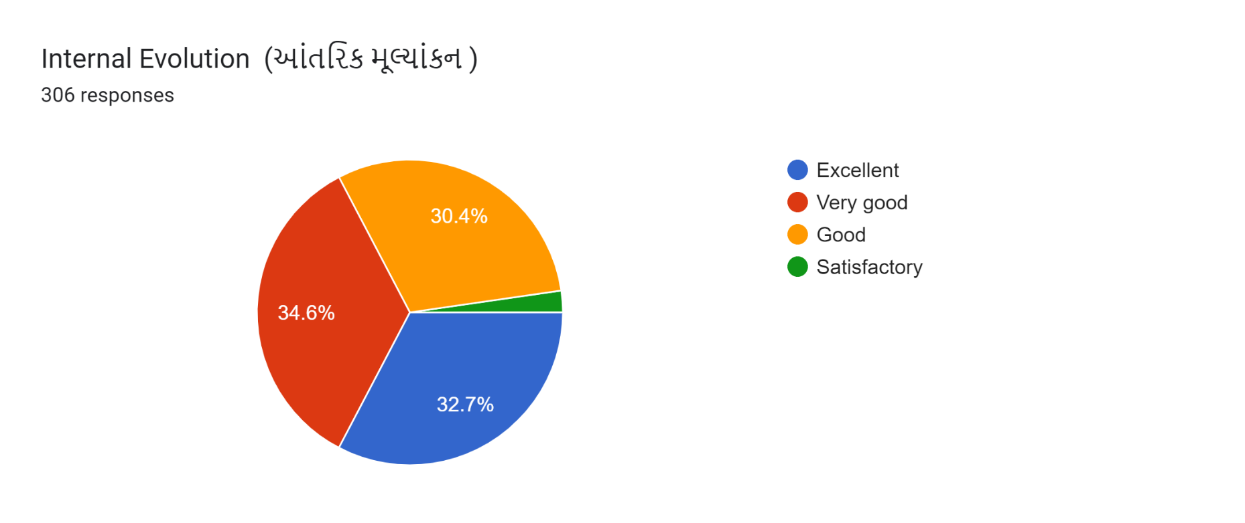
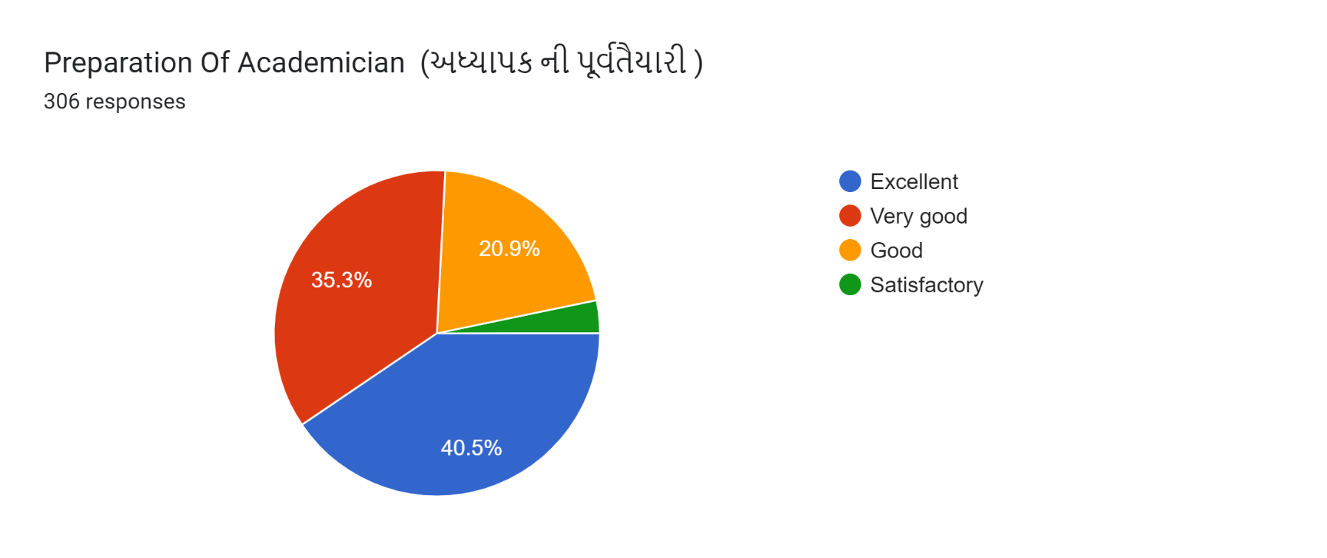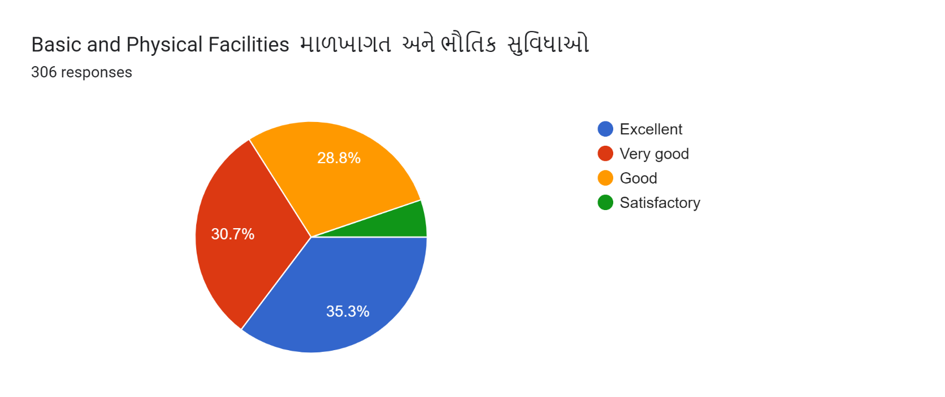

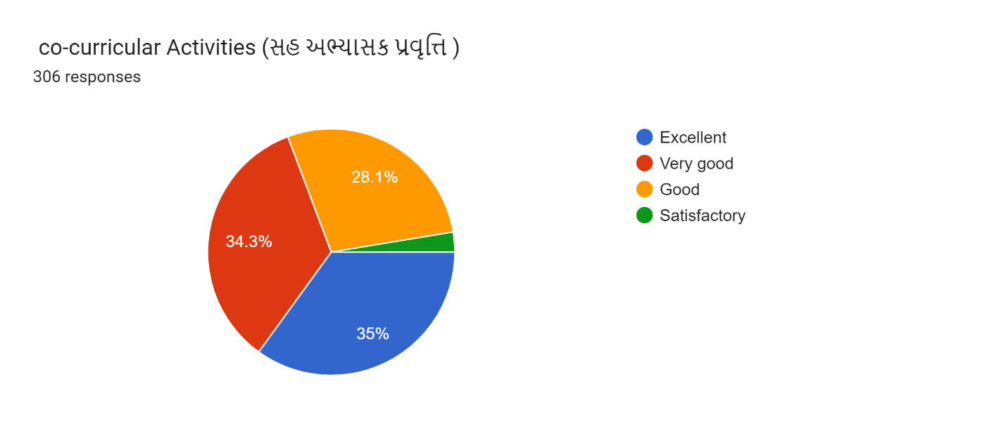
Average of SSS
Excellent= 36.85
Very Good =34.62
Good = 25.16
Satisfactory = 3.37

